Most people with respiratory infections like colds, the flu, and Coronavirus Disease (COVID-19) will have mild illness and can get better with appropriate home care and without the need to see a medical provider. People who are elderly, pregnant, or have a weak immune system, or other medical problem are at higher risk of more serious illness or complications. It is recommended that they carefully monitor their symptoms closely and seek medical care early.

Treatment
There is no specific treatment for most viruses, including those that that cause the common cold and those that cause COVID-19. Sometimes there is treatment for the viruses that cause influenza if given soon after the onset of symptoms. Antibiotics treat infections caused by bacteria, but they do not work against viruses.
Most people recover on their own from these viruses, including COVID-19. Here are steps that you can take to help you get better:
• Rest
• Drink plenty of fluids
• Take over-the-counter cold and flu medications to reduce fever and pain. Follow the instructions on the package, unless your doctor gave you specific instructions. Note that these medicines do not ‘cure’ the illness and do not stop you from spreading germs.
When to Seek Medical Care
You should seek medical care if you are not getting better within a week, or if your symptoms get worse. It is best to call your doctor ahead of time to discuss your symptoms, if possible. Some providers offer telemedicine services that can assist with your treatment without requiring you to leave home. This may allow you to receive the advice you need by phone. By avoiding a visit to a healthcare facility, you protect yourself from getting a new infection and protect others from catching an infection from you. If you do visit a healthcare facility, put on a mask to protect other patients and staff.

It is recommended that you seek medical care and return immediately to the Emergency Department for any serious symptoms, such as: 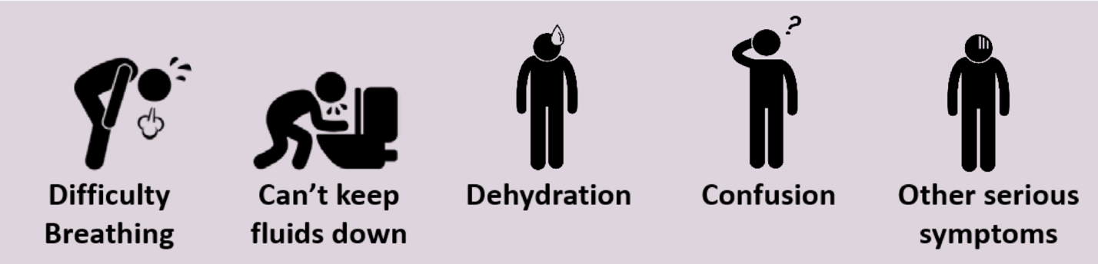

Return immediately for any difficulty breathing, confusion, dizziness or passing out, vomiting, high fevers, weakness, or any other new or concerning symptoms.
** People with potentially life-threatening symptoms should call 911. If possible, put on a facemask before emergency medical services arrive.
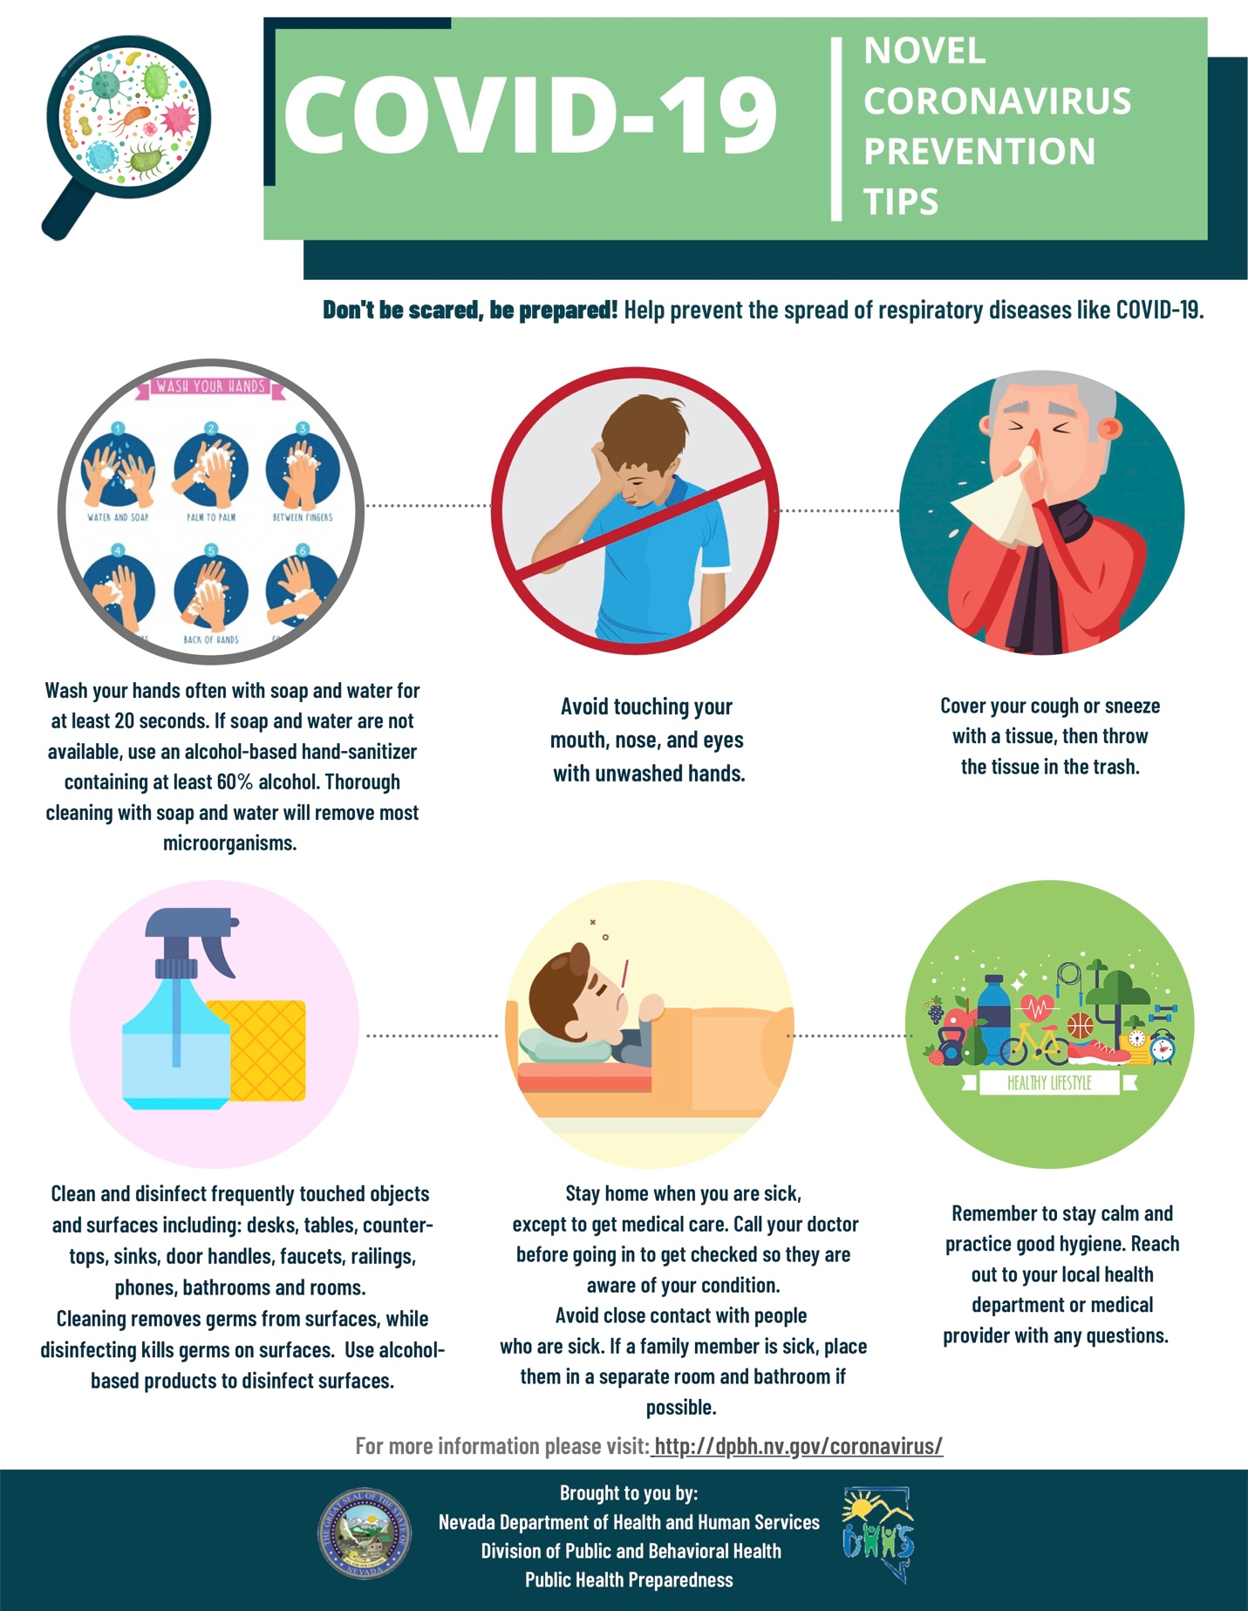

What should I do if home isolation has been recommended?
The following instructions are provided to assist you to safely care for yourself or others who are infected or potentially infected with COVID-19. These instructions are also available at: https://www.cdc.gov/coronavirus/2019-ncov/hcp/guidance-prevent-spread.html

It has determined that you do not need to be hospitalized at this time, and can therefore be safely be isolated at home. You should follow the prevention steps below until a health care provider or local health department says you can return to your normal activities.

Stay home except to get medical care
You should restrict activities outside your home, except for getting medical care. Under no circumstance should you go to work, school, or public areas. Avoid using public transportation, ride sharing, or taxis.

Separate yourself from other people and animals in your home
People: As much as possible, you should stay in a specific room and away from other people in your home. Also, you should use a separate bathroom, if available.

Animals: You should restrict contact with pets and other animals while you are sick with COVID-19, just like you would around other people. Although there have not been reports of pets or other animals becoming sick with COVID-19, it is still recommended that people with COVID-19 limit contact with animals until more information is known about the virus. When possible, have another member of your household care for your animals while you are sick. If you must care for your pet or be around animals while you are sick, wash your hands before and after you interact with pets and wear a facemask.

Call ahead before visiting your doctor
If you have a medical appointment, call the health care provider prior to your appointment and tell them that you have or may have COVID-19. This will help the health care provider’s office take steps to keep other people from getting infected or exposed. Ask your health care provider to call the local or state health department. Persons who are placed under active monitoring or facilitated self-monitoring should follow instructions provided by their local health department or occupational health professionals, as appropriate. If you have a medical emergency and need to call 911, notify the dispatch personnel that you have, or are being evaluated for COVID-19. If possible, put on a facemask before emergency medical services arrive.

Take care of your mental health
You might be feeling anxious, afraid, lonely or uncertain. The following link has a guide with a list of helpful behavioral health resources, and a few tips for taking care of your emotional health while you're quarantined:
https://store.samhsa.gov/system/files/sma14-4894.pdf

Wear a face mask
You should wear a facemask when you are around other people (for example, sharing a room or vehicle) or pets, and before you enter a health care provider’s office. If you are not able to wear a facemask (for example, because it causes trouble breathing), then people who live with you should not stay in the same room with you, or they should wear a facemask if they enter your room.

Cover your coughs and sneezes
Cover your mouth and nose with a tissue when you cough or sneeze. Throw used tissues in a lined trash can.

Clean your hands often
Wash your hands often with soap and water for at least 20 seconds or clean your hands with an alcohol-based hand sanitizer that contains 60 to 95% alcohol, covering all surfaces of your hands and rubbing them together until they feel dry. Soap and water should be used preferentially if hands are visibly dirty. Avoid touching your eyes, nose, and mouth with unwashed hands.

Avoid touching your face
Viruses that affect the respiratory system enter the body through mucous membranes which are found in the eyes, nose, and mouth. It only takes one touch for germs on your fingers to enter your body through your nostril, eyes or mouth. In addition to hand hygiene, this is an important way to prevent transmission of infections.

Clean all high-touch surfaces every day

High-touch surfaces include counters, tabletops, doorknobs, bathroom fixtures, toilets, phones, keyboards, tablets, and bedside tables. Also, clean any surfaces that may have blood, stool, or body fluids on them. Use a household cleaning spray or wipe, according to the label instructions. Labels contain instructions for safe and effective use of the cleaning product including precautions you should take when applying the product, such as wearing gloves and making sure you have good ventilation during use of the product.

Avoid sharing personal household items
You should not share dishes, drinking glasses, cups, eating utensils, towels or bedding with other people or pets in your home. After using these items, they should be washed thoroughly with soap and water.

Monitor your symptoms
Please contact the Southern Nevada Health District (SNHD) as soon as possible. Persons who are placed under active monitoring or facilitated self-monitoring should follow instructions provided by their local health department or occupational health professionals, as appropriate.

https://www.southernnevadahealthdistrict.org/coronavirus

For specific questions and answers about COVID-19, call the SNHD info line at (702) 759-INFO (4636)
Monday–Friday 7 a.m.–7 p.m • Saturday and Sunday 8 a.m.–4 p.m.
- Additional information is available at: dpbh.nv.gov/coronavirus or call 800-860-0620, Monday through Friday, 7 a.m. to 7 p.m.

Seek immediate medical attention if your illness is worsening: difficulty breathing, confusion, dizziness or passing out, vomiting, high fevers, weakness, or any other new or concerning symptoms. Before seeking care, call your health care provider and tell them that you have, or are being evaluated for COVID-19. Put on a facemask before you enter the facility. These steps will help keep other people in the office or waiting room from getting infected or exposed.

If you have a medical emergency and need to call 911, notify the dispatch personnel that you have, or are being evaluated for COVID-19. If possible, put on a face mask before emergency medical services arrive.

Discontinuing home isolation
Patients with confirmed COVID-19 should remain under home isolation precautions until the risk of secondary transmission to others is thought to be low. The decision to discontinue home isolation precautions is made on a case-by-case basis, in consultation with health care providers, and state and local health departments.

Recommended precautions for household members, intimate partners, and caregivers:
If you are providing care for a person infected or suspected to be infected with COVID-19, please note the following. These instructions are also available at: https://www.cdc.gov/coronavirus/2019-ncov/hcp/guidance-prevent-spread.html

How do I take care of someone who is quarantined in my home?
If you are providing care for a person infected or suspected to be infected with COVID-19, please note the following. These instructions are also available at CDC.gov.
Household members, intimate partners, and caregivers in a non-health care setting may have close contact (within 6 feet) with a person with symptomatic, laboratory-confirmed COVID-19 or a person under investigation. Those in close contact should monitor their health and should call their health care provider right away if they develop symptoms suggestive of COVID-19 (such as fever, cough, shortness of breath).
Those in close contact should also follow these recommendations:
- Make sure that you understand and can help the patient follow their health care provider’s instructions for medication(s) and care. You should help the patient with basic needs in the home and provide support for getting groceries, prescriptions and other personal needs
- Monitor the patient’s symptoms. If the patient is getting sicker, call his or her health care provider and tell them that the patient has laboratory-confirmed or is under investigation for COVID-19. This will help the health care provider’s office take steps to keep other people in the office or waiting room from getting infected. Ask the health care provider to call the local or state health department for additional guidance. If the patient has a medical emergency and you need to call 911, notify the dispatch personnel that the patient has, or is being evaluated for COVID-19
- Household members should stay in another room or be separated from the patient as much as possible. Household members should use a separate bedroom and bathroom, if available
- Prohibit visitors who do not have an essential need to be in the home
- Household members should care for any pets in the home. Do not handle pets or other animals while sick
- Make sure that shared spaces in the home have good airflow, such as by an air conditioner or an opened window, weather permitting
- Perform hand hygiene frequently. Wash your hands often with soap and water for at least 20 seconds or use an alcohol-based hand sanitizer that contains 60 to 95% alcohol, covering all surfaces of your hands and rubbing them together until they feel dry. Soap and water should be used preferentially if hands are visibly dirty
- Avoid touching your eyes, nose, and mouth with unwashed hands
- You and the patient should wear a facemask if you are in the same room
- Wear a disposable facemask and gloves when you touch or have contact with the patient’s blood, stool, or body fluids, such as saliva, sputum, nasal mucus, vomit or urine.
- Do not reuse disposable facemasks and gloves. Throw them away after using them.
- When removing personal protective equipment, first remove and dispose of gloves. Then, immediately clean your hands with soap and water or alcohol-based hand sanitizer. Next, remove and dispose of facemask, and immediately clean your hands again with soap and water or alcohol-based hand sanitizer
- Avoid sharing household items with the patient. You should not share dishes, drinking glasses, cups, eating utensils, towels, bedding or other items. After the patient uses these items, you should wash them thoroughly (see below)
- Clean all high-touch surfaces, such as counters, tabletops, doorknobs, bathroom fixtures, toilets, phones, keyboards, tablets and bedside tables, every day. Also, clean any surfaces that may have blood, stool, or body fluids on them
- Use a household cleaning spray or wipe, according to the label instructions. Labels contain instructions for safe and effective use of the cleaning product including precautions you should take when applying the product, such as wearing gloves and making sure you have good ventilation during the use of the product
- Wash laundry thoroughly
  - Immediately remove and wash clothes or bedding that have blood, stool, or body fluids on them
  - Wear disposable gloves while handling soiled items and keep soiled items away from your body. Clean your hands (with soap and water or an alcohol-based hand sanitizer) immediately after removing and throwing away your gloves
  - Read and follow directions on labels of laundry or clothing items and detergent. In general, using a normal laundry detergent according to washing machine instructions and dry thoroughly using the warmest temperatures recommended on the clothing label
- Place all used disposable gloves, facemasks, and other contaminated items in a lined container before disposing of them with other household waste. Clean your hands (with soap and water or an alcohol-based hand sanitizer) immediately after handling these items. Soap and water should be used preferentially if hands are visibly dirty
- Discuss any additional questions with your state or local health department or health care provider

What if I live with someone who's been told to self-quarantine?
- If the person you live with is NOT exhibiting respiratory symptoms, you can go about your day-to-day business, and you do not need to be tested or monitored.
- If the person you live with has respiratory symptoms (such as coughing or sneezing), but has not yet tested positive for COVID-19:
  - Please make sure to stay home
  - Monitor your symptoms closely, and seek medical attention if your symptoms are worsening
  - Avoid public areas and public transportation
  - Wear a facemask if you are sick
  - Cover your coughs and sneezes with a tissue, dispose of the tissue and immediately wash your hands
  - Wash your hands often for at least 20 seconds, and if soap and water are not available, use hand sanitizer
  - Avoid touching your eyes, nose or mouth
  - Avoid sharing personal household items
  - Clean "high-touch" surfaces daily
- If the person you live with has tested positive for COVID-19, you will be considered a close contact, and will also likely be asked to self-quarantine.

